**Proposal for Statistics Project on Knocking**

**contributors:**

**Jonathan Wilson (proposal), Jesse Van Horn (final report), Joe Lyon (proposal),**

**Rex Henretta (R and analysis), Christian Price (experiment), Jason Biesinger (R and analysis)**

**Introduction:**

Engine knock, or a ping sound that you hear coming from your engine, is actually a pressure wave created in the engine cylinder. It is caused by premature ignition of the cylinder’s air/fuel mixture. It can decrease engine efficiency, engine power, and if untreated can even destroy the engine. To fix this, octane is added to increase the combustion temperature of the air/fuel mixture, which causes the mixture to ignite at the right time.

The purpose of this designed experiment is to investigate how different levels of octane and different brands of octane additive affect engine knock. The focus of this experiment is not to test engines, nor what type of engines knock more frequently, but to only test the octane we add. In fact, a single-cylinder test engine made specifically for testing engine knock will be used. This is different from a normal automotive engine simply in that it is over-engineered to handle the damage that would normally result to an auto engine from knocking. Also, the fact that it’s only a single-cylinder engine eliminates the timing problems that often result from knock. However, these differences should have little effect on the experiment; they simply reduce the effect of other factors that affect overall performance but not necessarily engine performance. Effectiveness will be inferred by how little the engine knocks for a given air-fuel ratio and octane level. This is relevant to the average car driver because engine knock affects engine performance and service life. The fundamental question is: Does an octane boost additive reduce the knock in your engine? If so, how much?

**Experiment** **and methodology:**

Experimental unit: Knock limited indicated mean effective pressure (klimep) In this experiment we are looking specifically at the amount the pressure changes due to the addition of our factors (listed below). The greater the klimep, the more severe the knock is and the more harmful it is to the engine.

Response variable: Klimep level. The amount of pressure will be the response variable in our experiment, as this is what we expect to change throughout the experiments.

Factors: Air/fuel ratio, octane booster. Octane boosters will raise to the same octane level but be different brands, for randomization. They will be added to regular 87 octane gas.

3 Levels:

|  |  |
| --- | --- |
| Octane Booster Type | Air/fuel Ratio |
| Regular 87 (no octane) | Lean |
| Octane Booster #1 | Stoichiometric |
| Octane Booster #2 | Rich |

Procedures: The fact we use the same engine for all tests is greatly more important than the type of engine we use. That being said, will be using a one cylinder, varying compression, Cooperative Fuel Research (CFR) engine. This engine was specifically designed to measure engine knock, and when set to the appropriate settings, will consistently produce engine knock every revolution. It is ideal for testing because its results apply to real engines, it is designed to take the punishment and stress of knock, and real engines are too complex to test on. Real engines are defined as multi-cylinder engines connected to a drivetrain that are used in automobiles. Many accompanying issues of knock like timing and damage that are simplified out in this experiment will still be present in real engines. It will be attached to an American Society for Testing Materials (ASTM) knock meter that responds to the change in pressure in the cylinder to measure the severity of knock.

The CFR engine has three reservoirs attached to the fuel injector port. We will fill them with regular gas (no octane boost added), gas with octane boost #1, and gas with octane boost #2. If we were to start the testing immediately after starting the engine, the engine would warm-up and change temperatures. As the engine changes temperature, the klimep will change proportionally and our data would be ruined.To reduce this error, we will let the engine run for about 30 minutes without testing. This will allow the engine to warm up and reach a fairly stable temperature so it will not effect our data. This is possible with the aid of a motoring dynamometer that will turn the crank shaft.

Another source of possible error is when we produce the knock. The knock’s pressure wave can also increase the heat in the engine cylinder, thus the engine temperature and ultimately the klimep may vary inducing a potential of minor error in our measurements.

After the engine has warmed up, we will conduct our experiment following the Randomized Experiment Table. Between each run, we will wait 30 seconds and then test each run and record the klimep. Waiting 30 seconds between each test gives the engine enough time to adjust from the old air-fuel ratio and octane level to the new fuel settings. To change the levels, we will adjust a knob that controls the amount of fuel that is allowed to enter the cylinder. The more fuel that is above the knob, the more fuel is allowed to enter the the engine cylinder. When changing to the different fuels we will turn a different knob that switches between all three of the reservoirs that lead into the engine cylinder.

In order to receive sufficient data, as well as reduce the influence of outliers in engine performance and human error, we will run two replicates of each combination. Allowing for about a minute for each run to setup and perform the experiment at each setting, as well as 5-10 minutes to warm up the engine at the beginning of the experiment and fill up the reservoirs, we estimate it would take about 20 minutes to perform each set of replicates. We are limiting the experiment to two replicates in the interest of time (this is the busiest part of the semester for all of us) and cost of fuel and octane boosters. It is also a sufficient amount of replicates to receive the data we need.

There is a chance for some interesting results. Octane boosters can cost a lot of money, and it would be surprising to see that octane additives do nothing to help knock, and that we’ve been wasting our money this whole time. There is a chance that some of the lesser known or cheaper octane brands perform better than the more expensive and better known ones.

**Table of Randomized Experimental Combinations:**

|  |  |  |  |  |
| --- | --- | --- | --- | --- |
| Run # | Air/fuel ratio | Octane level  (Fuel Resv.) | Replicate | Amount of Knocking |
| 1 | Lean | Booster #1 | 1 | 30 |
| 2 | Rich | Booster #2 | 1 | 58 |
| 3 | Stoichiometric | Regular | 1 | 82 |
| 4 | Lean | Regular | 1 | 75 |
| 5 | Stoichiometric | Booster #1 | 1 | 70 |
| 6 | Lean | Booster #1 | 2 | 30 |
| 7 | Lean | Booster #2 | 1 | 55 |
| 8 | Stoichiometric | Booster #2 | 1 | 75 |
| 9 | Rich | Booster #1 | 1 | 46 |
| 10 | Lean | Regular | 2 | 72 |
| 11 | Rich | Regular | 1 | 61 |
| 12 | Rich | Regular | 2 | 64 |
| 13 | Stoichiometric | Booster #2 | 2 | 76 |
| 14 | Lean | Booster #2 | 2 | 58 |
| 15 | Rich | Booster #1 | 2 | 43 |
| 16 | Stoichiometric | Regular | 2 | 85 |
| 17 | Stoichiometric | Booster #1 | 2 | 70 |
| 18 | Rich | Booster #2 | 2 | 57 |

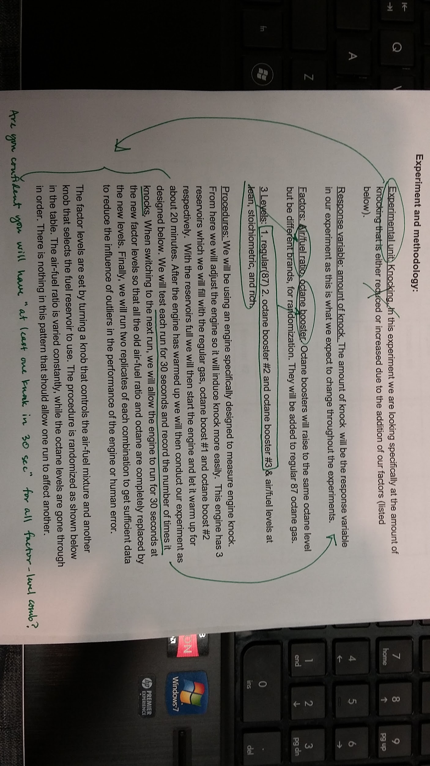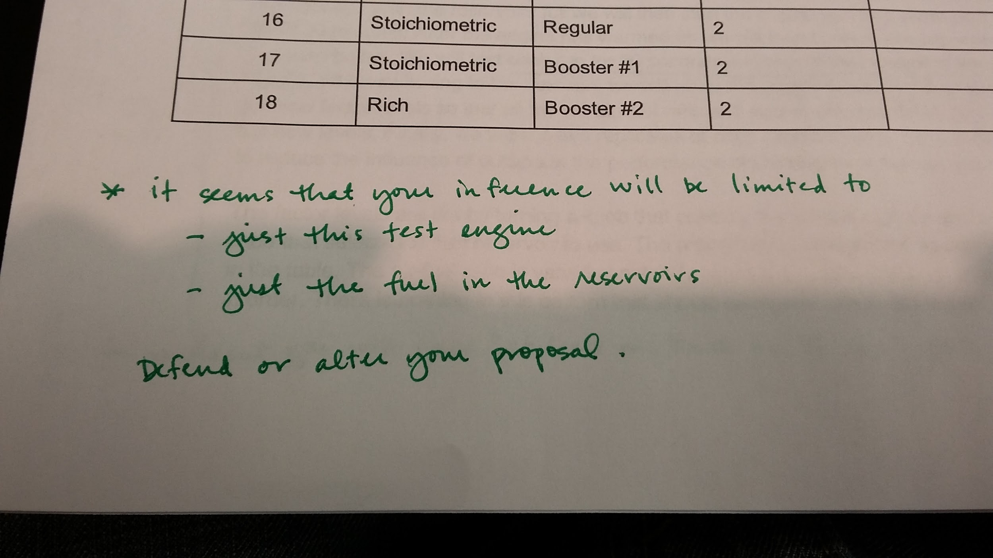

**Second set of notes:**